Lab 13. Calling the SharePoint API from a flow

**Learning objective:** out of the box, Flow actions cover an essential part of the SharePoint API. However, some features are not covered, and you need to invoke the SharePoint API. That what the **Send an HTTP Request to SharePoint** action is all about.

**Duration:** 30 minutes

**Scenario:** in this example, we will create a Flow that will add a new currency field called “Price” to an existing SharePoint list. No existing out of the box action covers this.

Tasks:

Make sure you are familiar with the SharePoint REST API; if not, read this documentation <https://docs.microsoft.com/en-us/sharepoint/dev/sp-add-ins/working-with-lists-and-list-items-with-rest>, most specifically the section “The following example shows how to **create a custom field for a list”.**

Go to one of your SharePoint list settings:

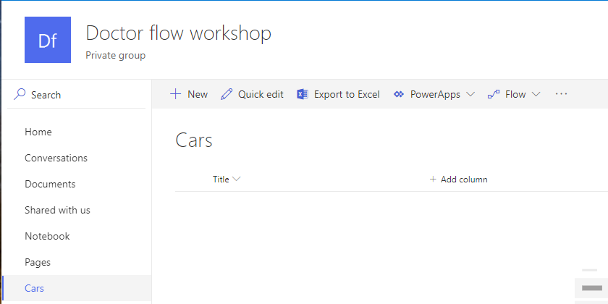

Copy the **list URL** to Notepad; we’ll need to use its **GUID**.



Copy the **list ID**, but remove the first tree and last tree characters:



Create a new Flow from scratch. The Flow must start with a Button.

Add a **Send an HTTP request to SharePoint** action defined like this (use your SharePoint URL and the list guid that you copied to notepad):

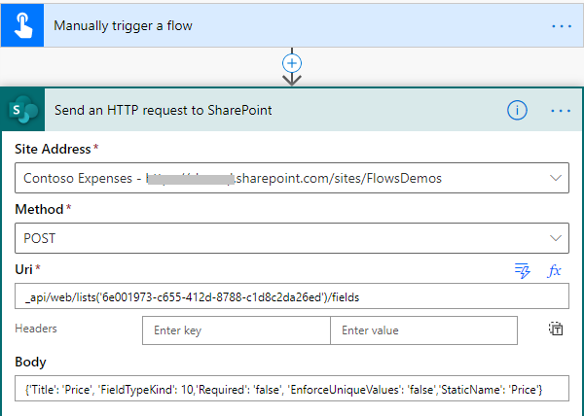

And in the body:

{'Title': '<yourfirstnamelastname>', 'FieldTypeKind': 10,'Required': 'false', 'EnforceUniqueValues': 'false','StaticName': 'Price_<yourfirstnamelastname>'}

Save and run your Flow. Typically, you will have a new column named “Price_<yorfirstnamelastname”.

**We need your feedback**

Do you want to report an issue or to suggest something? We need your feedback: <https://github.com/Power-Automate-in-a-day/Training-by-the-community/issues>